Data Visualisation 1 Report

Dataset: [Forbes Billionaires and Companies 2022 | Kaggle](https://www.kaggle.com/datasets/shrikrishnaparab/forbes-billionaires-and-companies-2022?resource=download)

Tableau Dashboard link: [RuiQin30874157 | Tableau Public](https://public.tableau.com/app/profile/f2319886979.rui.qin/viz/RuiQin30874157/Dashboard?publish=yes)

Word count: 790

# Description of the Domain, Why, and Who

In the domain of wealth, understanding the dynamics of the world's billionaires is important. Forbes is a source for such information and publishes a ranking of the world's richest (Forbes, 2023). This report presents a data visualisation project that focuses exclusively on Forbes' 2022 Billionaires dataset. This aims to provide users with an insightful idea to explore and analyse the demographics and wealth distribution of these billionaires.

**Why**: The visualisation shows the distribution of wealth among the world's billionaires, and it explores factors such as age, gender, source of wealth, and more.

**Who**: This visualisation is designed for people such as researchers, journalists, students, and anyone interested in getting a deeper understanding of the world's wealthiest people.

# Description of the Data (What)

The dataset was collected and compiled by Forbes, a reputable publisher in the field of wealth and finance. It was created through a rigorous process of data collection, verification, and analysis, ensuring the information is relevant and accurate. The dataset used for this visualisation is sourced from Kaggle and it includes information such as the rank of billionaires, their names, ages, net worth, industry, associated companies, countries, self-made status, gender, and birthdates.

# Rationale for Choosing Specific Idioms

## Top Richest People Bar Chart (Rank 1-35)

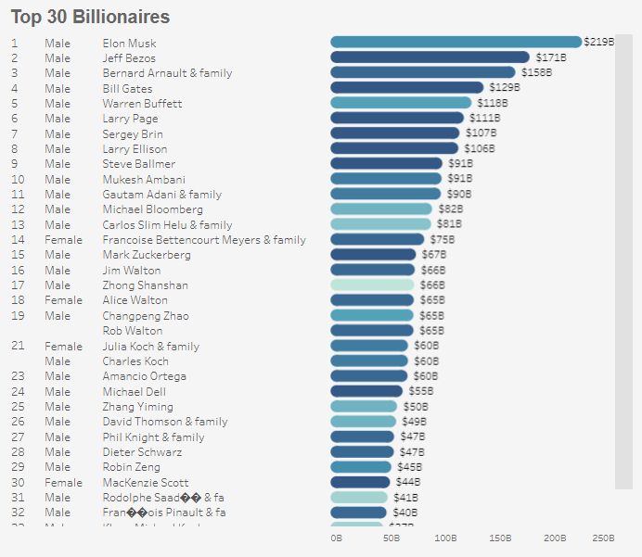

This chart provides a quick overview of the world's wealthiest people, allowing users to know the elite at the top of their wealth quickly and compare their wealth.

## Top 50 Country Bar Chart with Map

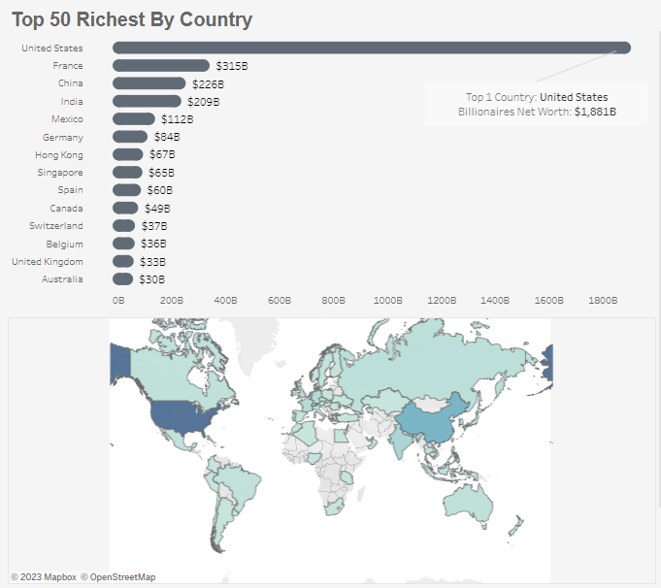

Geographic wealth distribution is a key aspect of the dataset, and this chart visually highlights the economic disparities among countries, it allows users to identify countries with the highest concentration of billionaires and discern global wealth maps.

## Industry Bar Chart

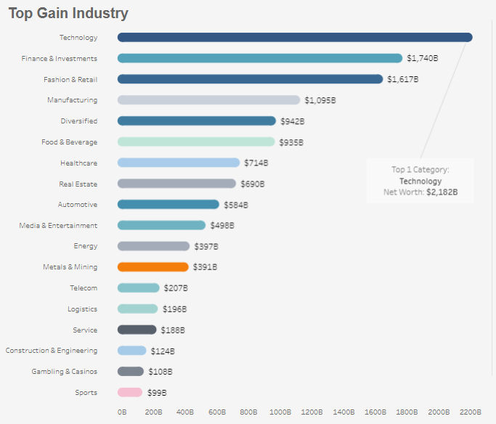

Sorting industries by final worth provides insights into which industry generates the most wealth. Industry affiliations provide context for how billionaires amassed their wealth, which empowers users to investigate which industries provide billionaire wealth.

## Sankey Diagram

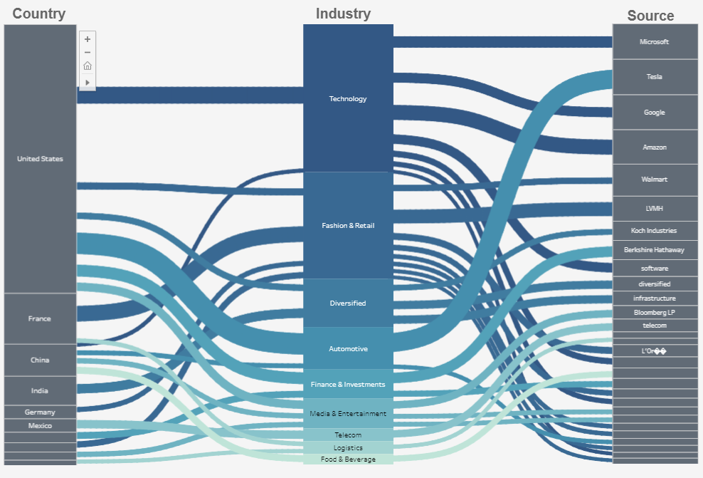

The Sankey diagram visually connects three key dimensions: Country, Industry, and Company. This interactive diagram allows users to explore the deep connections between these dimensions, uncovering correlations and dependencies and enabling deep analytical insights.

Self-Made vs. Not Self-Made Bar Chart with Gender Percentage

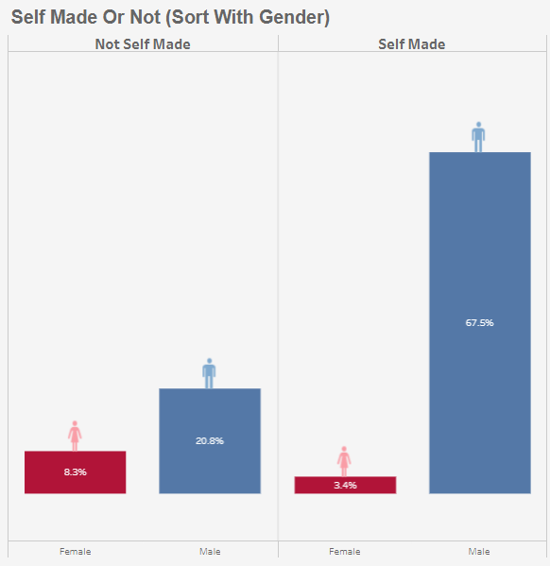

This chart highlights the percentage of self-made billionaires and highlights gender diversity in this category. Given the self-made status and gender representation in the billionaire dataset, this visualisation comes into focus. Users can quickly know the proportion of self-made billionaires while showing gender differences to facilitate conversations about wealth creation and diversity.

## Stacked Bar Chart (Age & Gender vs. Average Net Worth)

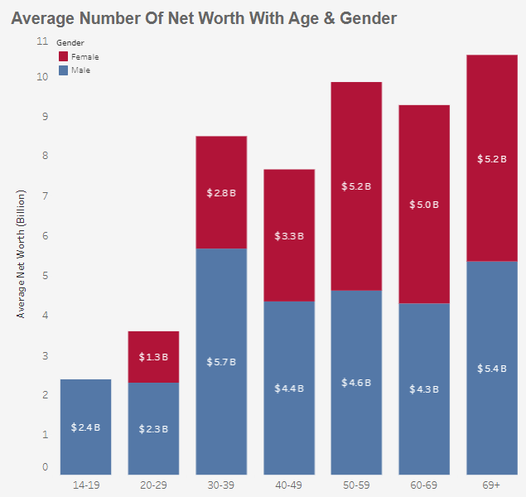

This chart provides the wealth gap between different ages and genders. Age and gender are key factors in wealth accumulation, and this chart is an important tool to uncover these differences. Users can delve into how average net worth fluctuates across age and gender categories to get a view of wealth inequality.

# Design

## Layout

The layout is structured with a clear focus on user intuitiveness and comparability. Charts are organised in columns and rows, providing a logical flow that enables users to seamlessly navigate through the visualization from top to bottom. This arrangement ensures that users can easily explore and make connections between different aspects of billionaire data, such as wealth distribution, demographics, and industry affiliations.

## Colour

A blue theme is selected to create a comfortable reading environment that doesn't overwhelm users (Braam, 2015). This gentle colour scheme provides a sense of maturity and trustworthiness. Gray is used for the classification of countries and companies, which describes the categories without distracting attention. Blue teal is chosen to represent the industries. This colour is more vibrant in visualization, making industry-relevant data stand out. The colours for men and women are dark Blue and pink respectively. These two colours can let people know the classification of men and women at a glance, and the blue used is different from blue teal.

## Figure-Ground

To establish a clear visual hierarchy, graphic elements are different in size, colour, and location. Key information, such as top billionaires or important data points, is displayed prominently and can be linked to the Sankey chart while maintaining an overall aesthetic balance.

## Typography

Typography plays an important role in readability. We've opted for a clean and legible typeface throughout the visualization, enhancing the overall readability of text and labels. The font size and layout are thoughtfully adjusted to prioritize clarity and aesthetics, ensuring that users can effortlessly engage with the content.

## Storytelling

Users are guided through the visualisation with annotations and interactivity. The Sankey diagram's interactive feature encourages exploration, and annotations provide explanations where necessary, ensuring a seamless narrative flow.

# Reference

Forbes. (2023). Billionaires 2023. Forbes. https://www.forbes.com/billionaires/

Braam, H. van. (2015). Blue Color: Psychology, Meaning and Symbolism. Color Psychology. https://www.colorpsychology.org/blue/#:~:text=In%20Western%20cultures%2C%20blue%20is

# Appendix

Five Design Sheets

